Lecture X
Sedatives and Hypnotics
Sedatives are drugs which exert a quietening effect accompanied by relaxation and rest but do not necessarily induce sleep. Hypnotics are drugs which induce sleep and are synonymous with somnifacient and saporific. Both hypnotic and sedative properties usually reside in the same drug ; a large dose of a drug may act as a hypnotic, whereas a small dose of the same drug would act as a sedative. It is pertinent to mention here that in a few exceptional cases a compound exerts only one specific effect, e.g., potassium bromide is a good sedative and exhibits no hypnotic action ; likewise certain powerful hypnotics, e.g., thiopentone sodium cannot be used as a sedative.
Dier and sudden unforeseen ‘emotional crisis’ invariably create such clinical situations that exceptionally demand the essential use of sedatives and hypnotics. A plethora of insomnia (sleeplessness) inadvertently caused due to short-term ‘situational stress’ is usually regarded as the most suitable and ideal circumstantial condition(s) which necessiates drug-treatment not only to facilitate but also to augment sleep. After a vigorous and intensive research the introduction of rather newer yet safer and definitely more efficacious sedative and hypnotic drug has always been greeted with great fervour and optimism. In a broader perspective, therefore, an ‘ideal sedative and hypnotic’ must fulfil the following essential pre-requisites and requirements, namely :
(a) Must exert transient decrease in the degree of consciousness for the purpose of inducing sleep without any lingering effects,
(b) Should possess no potential for either lowering or arresting respirations (even at relatively higher dose regimens), and
(c) Essentially cause absolutely little abuse, dependence, addiction, or tolerance.
Interestingly, an honest and dedicated attempt to circumvent the already discussed undesirable characteristic features of ‘barbiturates’, have ultimately resulted to the synthesis of a host of ‘nonbarbiturate’ structural analogue as potential sedatives-hypnotics in early 1950s, namely : methaqualone, nitrazepam, glutethimide, methyprylon, that are specifically noteworthy.
The sedatives and hypnotics are broadly classified into the following two categories, namely :
(a) Barbiturates ; and
(b) Non-barbiturates.
2.1 Barbiturates
In general, the barbiturates exert a significant depressant action on the cerebrospinal axis. The relative degrees of depression, sedation, hypnosis or anaesthesia are exclusively dependent on the nature of the barbiturate, its dose and route of administration.
Barbiturates are cyclic ureides and are formed when a dicarboxylic acid reacts with urea. The acids used are generally in the form of ester and are condensed in the presence of sodium ethoxide (i.e., C₂H₅—ONa) e.g.

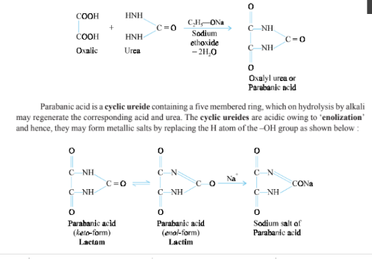
Many cyclic ureides are derived from malonic acid or malonic esters. They are collectively known as ‘barbiturates’ because of their relationship of malonyl urea or barbituric acid.
Barbituric acid is prepared by the following two methods:

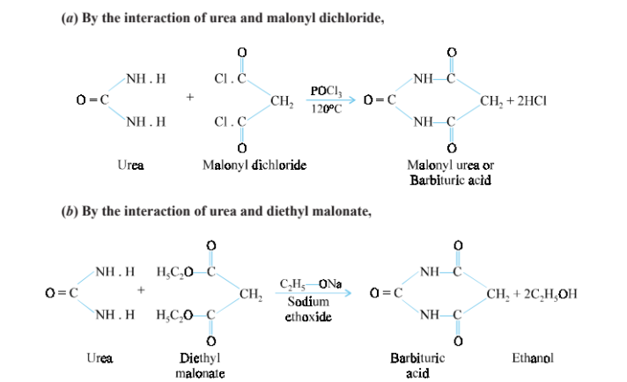

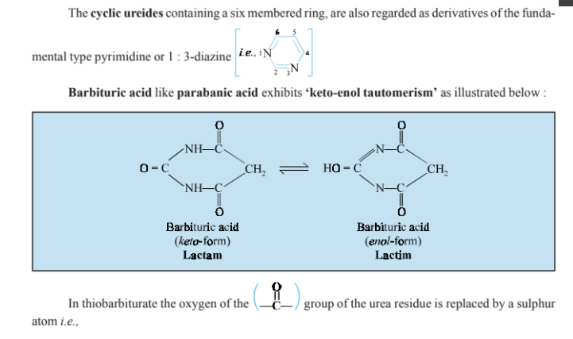
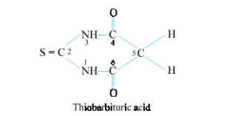

However, it is interesting to observe that the barbituric acid itself does not possess any hypnotic properties, but such a characteristic is conferred only when the hydrogen atoms at C-5 are replaced by organic groups (alkyl or aryl).
Classification of Barbiturates
Barbiturates are classified, rather arbitrarily, by the duration of their clinical effects. More than 50 derivatives are used in therapeutics. The more commonly used analogues of barbituric acid are re-corded.
A. Long Acting Barbiturates
The onset of action for long acting barbiturates is visible after an hour or so, and the duration of action lasts for 6–10 hours. They are largely excreted by the kidney. Examples : Barbitone ; Barbital Sodium ; Phenobarbital ; Methyl-phenobarbital.
A1. Barbital INN, Barbitone BAN,

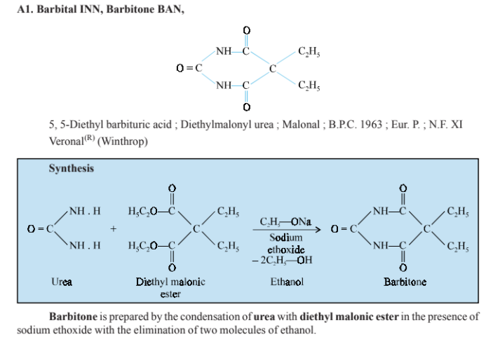

It is a powerful hypnotic drug and generally used in the treatment of epileptic seizures. It has the main drawback of having a low therapeutic index.
Dose : 0.3 to 0.6 g.
The solutions are incompatible with ammonium salts and acidic substances. A2. Barbital Sodium INN, Barbitone Sodium BAN :

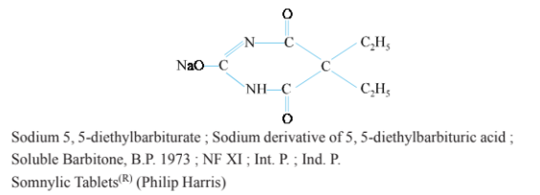

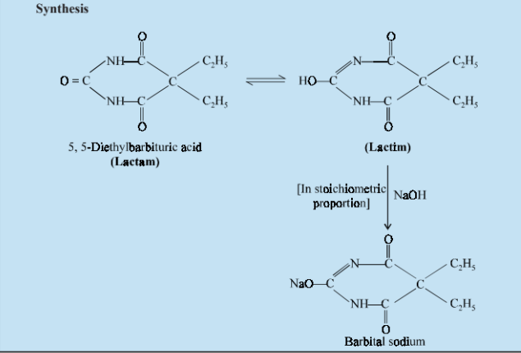

It is prepared by the neutralization of an aqueous solution of barbital with sodium hydroxide and then precipitating the salt by the addition of alcohol. Being water-soluble, barbital sodium is more readily absorbed than its parent compound barbital. Owing to its slow rate of excretion there exists an element of risk of a cumulative action. Dose: 0.34 to 0.6 g.
Although the brain is undoubtedly the most wondrously complex organ, it is possible to distil the way it works into two opposing forces; excitation and inhibition (depressing). Central nervous system (CNS) depressants are drugs that can be used to slow down or “depress” the functions of the CNS. Although many agents have the capacity to depress the function of the CNS, CNS depressants discussed in this chapter include only anxiolytics, sedative–hypnotics, and antipsychotics. There is some overlap between the first two groups. They often have several structural features in common and likewise often share at least one mode of action, positive modulation of the action of -aminobutyric acid (GABA) at GABAA receptor complex. The list of anxiolytic, sedative, and hypnotic drugs is a short one—benzodiazepines, Z-drugs, barbiturates, and a miscellaneous group. Antipsychotic drugs—previously known as neuroleptic drugs, antischizophrenic drugs, or major tranquilizers—are used in the symptomatic treatment of thought disorders (psychoses), most notably the schizophrenias. Antipsychotics are grouped into typical and atypical categories. Both categories share a common feature, a dopamine (DA)-like structure, often hydrophobically substituted. This feature can be related to the most commonly cited action of these agents, competitive antagonism of DA at D2 or occasionally D3 or D4 receptors in the limbic system. The fundamental differences between typical and atypical antipsychotics are that the atypical agents are (a) less prone to produce extrapyramidal symptoms (EPS), because they are less able to block striata D2 receptors vis-à-vis limbic D2 and D3 receptors, and (b) more active against negative symptoms (social withdrawal, apathy, anhedonia). ANXIOLYTIC, SEDATIVE, AND HYPNOTIC AGENTS In addition to benzodiazepines, barbiturates, and a miscellaneous group, many drugs belonging to other pharmacological classes may possess one or more of the anxiolytic, sedative, and hypnotic activities. An arbitrary classification of these agents is as follows: 1. GABAA receptor modulators • Benzodiazepines are highly effective anxiolytic and hypnotic agents (e.g., diazepam, chlordiazepoxide, prazepam, clorazepate, oxazepam, alprazolam, flurazepam, lorazepam, triazolam, temazepam, estazolam, and quazepam). They bind to benzodiazepine-binding sites on GABAA receptor (also known as benzodiazepine receptor [BzR]). They are sometimes called benzodiazepine receptor agonists (BzRAs). • Nonbenzodiazepine hypnotics (Z-drugs): Imidazopyridine (zolpidem), pyrazolopyrimidine (zaleplon), and cyclopyrrolone (zopiclone and its [S]-[]-enantiomer eszopiclone). • Barbiturates including amobarbital, aprobarbital, butabarbital, pentobarbital, phenobarbital, and secobarbital are largely obsolete and superseded by benzodiazepines. Their use is now confined to anesthesia and treatment of epilepsy. • General anesthetics and ethanol. 2. Melatonin-1 receptor (MT1) agonists. A new drug in this area is ramelteon (Rozerem).1 Currently, 10 Food and Drug Administration (FDA)-approved drugs for insomnia include nine BzRAs (five benzodiazepines, four nonbenzodiazepines) and ramelteon. 3. Atypical azaspirodecanediones: Buspirone is a partial 5- HT1A receptor agonist and an anxiolytic. It is less sedative and has less abuse potential. 4. Miscellaneous drugs such as chloral hydrate, meprobamate, and glutethimide are no longer recommended, but occasionally used. 5. Antipsychotics and anticonvulsants. It has been proposed that DA has a facilitative and active role in the sleep–wakefulness cycle. Waking appears to be a state maintained by D2 receptor activation, whereas blocking D2 receptor appears to cause sedation. 6. Antidepressants: Many antidepressants cause sedation, of which trazodone, doxepin, and mirtazapine have been shown to be effective in the treatment of insomnia in patients with depression. Several selective serotonin reuptake inhibitors (SSRIs), including escitalopram, fluoxetine, fluvoxamine, paroxetine, and sertraline, became the first-line therapy for some anxiety disorders in 1990s because they are not as addictive as benzodiazepines. 7. Sedative H1-antihistamines: diphenhydramine and doxylamine: Diphenhydramine is sometimes used as sleeping pills, particularly for wakeful children. It is proposed that histamine may have an involvement in wakefulness and rapid eye movement (REM) sleep. Histamine-related functions in the CNS are regulated at postsynaptic sites by both H1 and H2 receptors, whereas the H3 receptors appear to be a presynaptic autoreceptor regulating the synthesis and release of histamine. The H1 receptor agonists and the H3 receptor antagonists increase wakefulness, whereas the H1 receptor antagonists and H3 receptor agonists have the opposite effect. Another example of H1-antihistamines is doxylamine. 8. -Adrenoceptor antagonists (e.g., propranolol) are sometimes used by actors and musicians to reduce the symptoms of stage fright, but their use by snooker players to minimize tremor is banned as unsportsmanlike. 9. New areas explored for sleep-promoting agents: • Adenosine-2A receptor (A2A) agonists (adenosine is a possible endogenous sleep-producing agent). • Linoleamide and 9,10-octadecenoamide are possible endogenous sleep-producing agents and are positive modulators of GABAA receptors.2 • Anandamide is an endogenous cannabinoid that might be used as a lead to search for new hypnotics. The properties and side effects of FDA-approved hypnotics and commonly used but not FDA-approved hypnotics are reviewed.3,4 Older sedative–hypnotic drugs depress the CNS in a dose-dependent manner, progressively producing calming or drowsiness (sedation), sleep, unconsciousness, surgical anesthesia, coma, and eventually death from respiratory and cardiovascular depression. Although many factors influence the pharmacokinetic profile of sedatives and hypnotics, because most of them are in the nonionized form at physiological pH, their high lipophilicity is an important factor for following properties. (a) Most of them are absorbed well from the gastrointestinal (GI) tract, with good distribution to the brain. This property is responsible for the rapid onset of CNS effects of triazolam, thiopental, and newer hypnotics. (b) Many sedative–hypnotics cross the placental barrier during pregnancy. (c) They are also detectable in breast milk. (d) Some drugs with highest lipophilicity have short duration of action because of their redistribution. (e) Most drugs in this class are highly protein bond. (f) Metabolism to more water-soluble metabolites is necessary for their clearance from the body. Thus, the primary means of elimination of the benzodiazepines is metabolism, and most of them are extensively metabolized. Consequently, their duration of action depends mainly on the rate of metabolism and if their metabolites are active. Benzodiazepines are the most important drugs in both groups; therefore, the two groups are discussed together in the first section. GABAA Receptors, Benzodiazepines, and Related Compounds GABA system (deficiency of GABA activity in CNS) is important in the pathophysiology of anxiety and insomnia. GABA is the most common and major inhibitory neurotransmitter (NT) in the brain and it exerts its rapid inhibitory action mostly through GABA receptors. It is known to activate two types of receptors, the ionotropic GABAA and GABAC receptors and the metabotropic GABAB receptor. GABAA receptor is the target for many anxiolytics and sedative–hypnotic agents including benzodiazepines, barbiturates, zolpidem, zaleplon, eszopiclone, steroids, anticonvulsive agents, and many other drugs that bind to different binding sites of the GABAA receptors in neuronal membranes in the CNS.5,6 It is a ligand-gated chloride ion channel. Upon activation, Cl influx is increased and the membrane becomes hyperpolarized, resulting in neuronal inhibition. GABAA receptor exists as heteropentomeric transmembrane subunits arranged around a central chloride ion (Cl) channel. The five polypeptide subunits (each subunit has an extracellular N-terminal domain, four membrane-spanning domains, and an intracellular loop) that together make up the structure of GABAA receptors come from the subunit families, , , , , , , and . There are six isoforms of the -polypeptide (1–6), four of the with two splice variants, and three of the with two variants. Most receptors consist of, , and combinations. Of these, 1, 2, and 2 are most common. The most common pentomeric GABA receptor combination includes two 1, two 2, and one 2 subunit. Other highly expressed combinations are 2, 2, 2 and 2, 3, 2. The subunit composition of the receptors has great bearing on the response to benzodiazepines and other ligands. The multiplicity of subunits results in heterogeneity in GABAA receptors and is responsible, at least in part, for the pharmacological diversity in benzodiazepine effects. For example, , , and subunits confer benzodiazepine sensitivity to the receptors, whereas and subunits confer barbiturates sensitivity to the receptors. The benzodiazepine recognition site is in the extracellular N-terminus of the 1, 2, 3, and 5 subunits. Studies suggest that 1 subunits are required for hypnotic, amnesic, and possibly anticonvulsant effects of benzodiazepines, whereas 2 subunits are required for the anxiolytic and myorelaxant effects of benzodiazepines. The mutation to arginine of a histidine residue of the GABAA receptor 1 subunit render receptors containing that subunit insensitive to the enhancing hypnotic effects of diazepam. Whereas, if arginine replaces histidine in an 2 subunit, the anxiolytic effect of benzodiazepines is lost.5 In addition, 3 and 5 subunits may be involved in other actions of benzodiazepines; 4 or 6 subunits do not respond to benzodiazepines. Although the binding domain of the benzodiazepines is considered to be in the N-terminal domain of the subunit, the benzodiazepines also require a 2 subunit for most positive allosteric effects. Amino acid residues in the 1 subunit that have been identified as key binding sites within the benzodiazepine-binding site are His 101, Tyr 161, Thr 162, Gly 200, Ser 204, Thr 206, and Val 211. In the subunit, Phe 77 has been identified.2,5,7–12 When benzodiazepines bind to a benzodiazepine recognition site, one of several allosteric sites that modulate the effect of GABA binding to GABAA receptors located on GABA receptor complex, the benzodiazepines induce conformational (allosteric) changes in the GABA-binding site, thereby increasing the affinity of the receptor for GABA. As a result, the frequency of Cl channel openings is increased over that resulting from the binding of GABA alone, and the cell is further hyperpolarized, yielding a more pronounced decrease in cellular excitability. The benzodiazepines appear to have no direct effect on the GABAA complex or ionophore. Several newer agents that have structural characteristics broadly related to the benzodiazepines, including imidazopyridines (zolpidem), pyrazolopyrimidines (zaleplon), and cyclopyrrolone (eszopiclone), can act as positive modulators at the benzodiazepine 1 recognition site selectively with fewer side effects. Benzodiazepines and related compounds can act as agonists, antagonists, or inverse agonists at the benzodiazepine binding site on GABAA receptor.

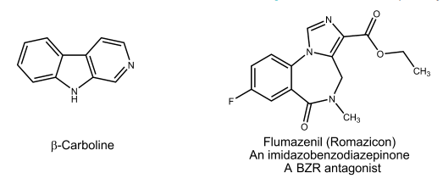
Most classical benzodiazepines are positive modulators (agonists), many probably nonselectively for all the receptor subtypes that respond to benzodiazepines. Some have been claimed to be relatively selective as T-drugs and anticonvulsants. Some -carbolines are negative modulators (inverse agonists) at benzodiazepine modulatory sites. Negative modulators diminish the positive effect of GABA on chloride flux. In whole animals, they appear to increase anxiety, produce panic attacks, and improve memory. There are also compounds that can occupy benzodiazepine modulatory sites, have no effect on chloride flux themselves, and block positive and negative modulators. They have been called variously antagonists, zero modulators, and neutralizing allosteric modulators. One such compound, flumazenil, is used clinically to counteract the sedative effect of benzodiazepines and benzodiazepine overdose. In addition to benzodiazepine allosteric modulatory sites, there are other allosteric sites that recognize respectively, barbiturates, inhalation anesthetics, alcohols, propofol (separate sites), and neurosteroids. The convulsants picrotoxin and pentylenetetrazole have definite binding sites on GABA receptors. The field of benzodiazepines was opened with the synthesis of chlordiazepoxide by Sternbach and the discovery of its unique pharmacological properties by Randall.13 Chlordiazepoxide (see the discussion on individual compounds) is a 2-amino benzodiazepine, and other amino compounds have been synthesized. When it was discovered that chlordiazepoxide is rapidly metabolized to a series of active benzodiazepine-2-ones (see the general scheme of metabolic relationships), however, emphasis shifted to the synthesis and testing of the latter group. Most benzodiazepines are 5-aryl-1,4-benzodiazepines and contain a carboxamide group in the seven-membered diazepine ring structure. Empirical structure–activity relationships (SARs) for antianxiety activity have been tabulated for this group (analogous statements apply for the older 2-amino group).13,14 The comparative quantitative SAR on nonbenzodiazepine compounds is also reviewed.15 The following general structure helps to visualize it (Fig. 12.1). Aromatic or heteroaromatic ring A is required for the activity that may participate in - stacking with aromatic amino acid residues of the receptor. An electronegative substituent at position 7 is required for activity, and the more electronegative it is, the higher the activity. Positions 6, 8, and 9 should not be substituted. A phenyl ring C at position 5 promotes activity. If this phenyl group is ortho (2) or diortho (2,6) substituted with electron-withdrawing groups, activity is increased. On the other hand, para substitution decreases activity greatly. In diazepine ring B, saturation of the 4,5-double bond or a shift of it to the 3,4-position decreases activity. Alkyl substitution at the 3-position decreases activity; substitution with a 3-hydroxyl does not. The presence or absence of the 3-hydroxyl group is important pharmacokinetically. Compounds without the 3-hydroxyl group are nonpolar, 3-hydroxylated in liver slowly to active 3-hydroxyl metabolites, and have long overall half-lives.
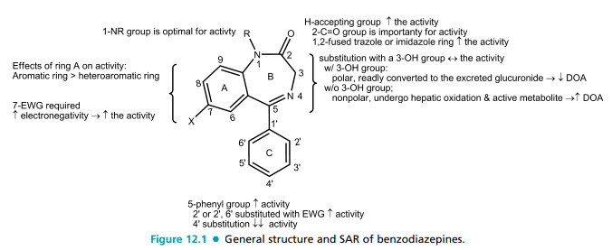
In contrast, 3-hydroxyl compounds are much more polar, rapidly converted to inactive 3-glucuronides, which are excreted in urine and thus are short-lived (Fig. 12.1). The 2- carbonyl function is important for activity, as is the nitrogen atom at position 1. The N1-alkyl side chains are tolerated. A proton-accepting group at C2 is required and may interact with histidine residue (as a proton donor) in benzodiazepinebinding site of GABAA receptor. Other triazole or imidazole rings capable of H-bonding can be fused on positions 1 and 2 and increase the activity. Additional research yielded compounds with a fused triazolo ring, represented by triazolam and alprazolam. Midazolam, with a fused imidazolo ring, also followed. These compounds are short acting because they are metabolized rapidly by -hydroxylation of the methyl substituent on the triazolo or imidazolo ring (analogs to benzylic oxidation). The resulting active -hydroxylated metabolite is quickly inactivated by glucuronidation. The compounds are also metabolized by 3-hydroxylation of the benzodiazepine ring. Interestingly, an electron-attracting group at position 7 is not required for activity in some of these compounds. The physicochemical and pharmacokinetic properties of the benzodiazepines greatly affect their clinical utility. Most benzodiazepines are lipophilic, in the nonionized form and thus well absorbed from the GI tract, whereas the more polar compounds (e.g., those with a 3-hydroxyl group) tend to be absorbed more slowly than the more lipophilic compounds. These drugs tend to be highly bound to plasma proteins; in general, the more lipophilic the drug, the greater the binding. However, they do not compete with other proteinbound drugs. They are also very effectively distributed to the brain. Generally, the more lipophilic the compound, the greater is the distribution to the brain, at least initially. When diazepam is used as an anesthetic, it initially distributes to the brain and then redistributes to sites outside the brain. The benzodiazepines are extensively metabolized. The metabolism of benzodiazepines has received much study.16,17 Some of the major metabolic relationships are shown in Figure 12.2. Metabolites of some benzodiazepines are not only active but also have long half-lives, thus these drugs are long acting. Many benzodiazepines are metabo
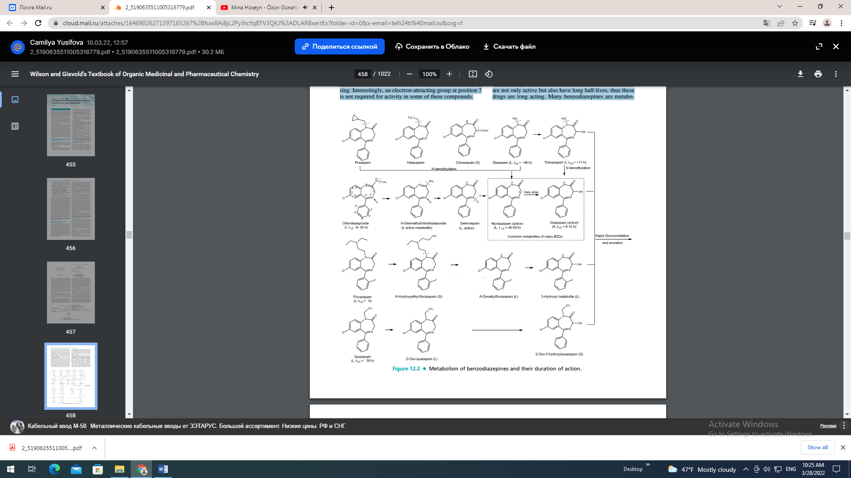
lized by cytochrome P450 (CYP) 3A4 and CYP2C19. CYP3A4 inhibitors (erythromycin, clarithromycin, ritonavir, itraconazole, ketoconazole, nefazodone, and grapefruit juice) can affect their metabolism. However, they do not induce the metabolism of other drugs. Therefore, the drugs have fewer drug interactions than barbiturates. In addition, they have lower abuse potential and a much greater margin of safety than the barbiturates. BENZODIAZEPINES Chlordiazepoxide Hydrochloride, United States Pharmacopeia (USP). Chlordiazepoxide hydrochloride, 7- chloro-2-(methylamino)-5-phenyl-3H-1,4-benzodiazepine 4-oxide monohydrochloride (Librium), is well absorbed after oral administration. Peak plasma levels are reached in 2 to 4 hours. The half-life of chlordiazepoxide is 6 to 30 hours. N-demethylation and hydrolysis of the condensed amidino group are rapid and extensive, producing demoxepam as a major metabolite. Demoxepam can undergo four different metabolic fates. It is converted principally to its active metabolite nordazepam, which is also a major active metabolite of diazepam, clorazepate, and prazepam. Nordazepam, in turn, is converted principally to active oxazepam (marketed separately), which conjugated to the excreted glucuronide. Because of the long half-life of parent drug and its active metabolites, this drug is long acting and self-tapering. As with diazepam (vide infra), repeated administration of chlordiazepoxide can result in accumulation of parent drug and its active metabolites, and thus cause excessive sedation. Diazepam, USP. Diazepam, 7-chloro-1,3-dihydro-1- methyl-5-phenyl-2H-1,4-benzodiazepine-2-one (Valium), is prototypical and was the first member of the benzodiazepine-2-one group to be introduced. It is very lipophilic and is thus rapidly and completely absorbed after oral administration. Maximum peak blood concentration occurs in 2 hours and elimination is slow, with a half-life of about 46 hours. As with chlordiazepoxide, diazepam is metabolized by N-demethylation to active nordazepam, which is 3-hydroxylated to active oxazepam (vide infra) and then metabolized according to the general scheme (Fig. 12.2). Like chlordiazepoxide, repeated administration of diazepam leads to accumulation of an active nordazepam, which can be detected in the blood for more than 1 week after discontinuation of the drug. This drug is a long acting for the same reason. Diazepam is metabolized to nordazepam by CYP2C19 and CYP3A4. Cimetidine, by inhibiting CYP3A4, decreases the metabolism and clearance of diazepam. Thus, drugs that affect the activity of CYP2C19 or CYP3A4 may alter diazepam kinetics. Because diazepam clearance is decreased in the elderly and in patients with hepatic insufficiency, a dosage reduction may be warranted. It is widely used for several anxiety states and has an additional wide range of uses (e.g., as an anticonvulsant, a premedication in anesthesiology, and in various spastic disorders). Prazepam, USP. Prazepam, 7-chloro-1-(cyclopropylmethyl)-1,3-dihydro-5-phenyl-2H-1,4-benzodiazepine-2-one (Verstran), has a long overall half-life. Extensive N-dealkylation occurs to yield active nordazepam. 3-Hydroxylation of both prazepam and nordazepam occurs.

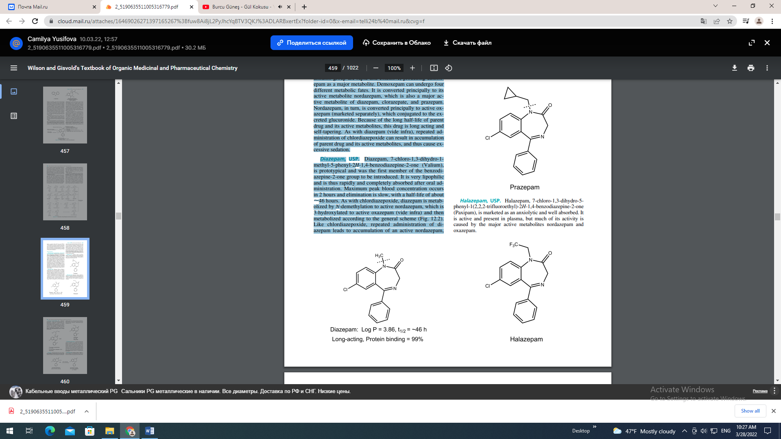
Halazepam, USP. Halazepam, 7-chloro-1,3-dihydro-5- phenyl-1(2,2,2-trifluoroethyl)-2H-1,4-benzodiazepine-2-one (Paxipam), is marketed as an anxiolytic and well absorbed. It is active and present in plasma, but much of its activity is caused by the major active metabolites nordazepam and oxazepam

Flurazepam Hydrochloride, USP. Flurazepam hydrochloride, 7-chloro-1-[2-(diethylamino)ethyl]-5-(2- fluorophenyl)-1, 3-dihydro-2H-1, 4-benzodiazepine-2-one dihydrochloride (Dalmane), is notable as a benzodiazepine marketed almost exclusively for use in insomnia. Metabolism of the dialkylaminoalkyl side chain is extensive. A major metabolite is N1 -dealkyl flurazepam, which has a very long half-life and persists for several days after administration. Consequently, it produces cumulative clinical effects and side effects (e.g., excessive sedation) and residual pharmacologic activity, even after discontinuation.
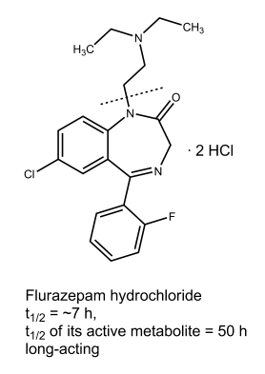
Quazepam. Quazepam (Doral) and its active metabolites reportedly are relatively selective for the benzodiazepine modulatory site on GABAA receptors with 1 subunit and are hypnotic agents. Quazepam is metabolized by Clorazepate Dipotassium. oxidation to the 2-oxo compound and then N-dealkylation. Both metabolites are active; the first reportedly is the more potent and selective. Thereafter, 3-hydroxylation and glucuronidation occur.
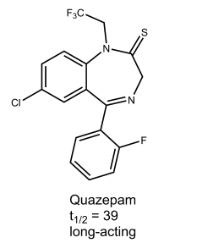
Clorazepate dipotassium, 7-chloro-2,3-dihydro-2-oxo-5-phenyl-1H-1,4-benzodiazepine-3-carboxylic acid dipotassium salt monohydrate (Tranxene), can be considered a prodrug. Inactive itself, it undergoes rapid decarboxylation by the acidity of the stomach to nordazepam (a major active metabolite of diazepam), which has a long half-life and undergoes hepatic conversion to active oxazepam. Despite the polar character of the drug as administered, because it is quickly converted in the GI tract to an active nonpolar compound, it has a quick onset, overall long half-life, and shares similar clinical and pharmacokinetic properties to chlordiazepoxide and diazepam. Oxazepam, USP. Oxazepam, 7-chloro-1,3-dihydro-3- hydroxy-5-phenyl-2H-1,4-benzodiazpin-2-one (Serax), is an active metabolite of both chlordiazepoxide and diazepam and can be considered a prototype for the 3-hydroxy benzodiazepines.
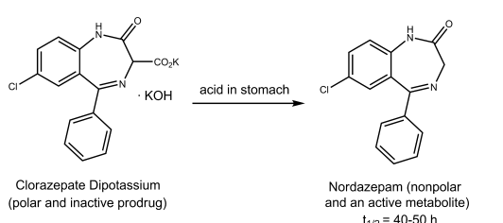

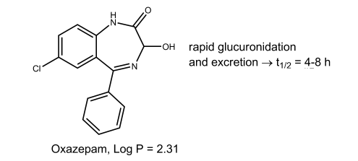
For the stereochemistry of this and other 3-hydroxy compounds, see the chapter dealing with metabolism. It is much more polar than diazepam. Oxazepam is rapidly inactivated to glucuronidated metabolites that are excreted in the urine. Thus, the half-life of oxazepam is about 4 to 8 hours, and it is marketed as a short-acting anxiolytic. As a result, its cumulative effects with chronic therapy are much less than with long-acting benzodiazepine such as chlordiazepoxide and diazepam. Lorazepam, USP. Lorazepam, 7-chloro-5-(2-chlorophenyl)-3-dihydro-3-hydroxy-2H-1,4-benzodiazepine-2-one (Ativan), is the 2-chloro derivative of oxazepam. In keeping with overall SARs, the 2-chloro substituent increases activity. As with oxazepam, metabolism is relatively rapid and uncomplicated because of the 3-hydroxyl group in the compound. Thus, it also has short half-life (2–6 hours) and similar pharmacological activity. Temazepam. Temazepam, 7-chloro-1,3-dihydro-3-hydroxy-1-methyl-5-phenyl -2H-1,4-benzodiazepine-2-one (Restoril), also occurs as a minor metabolite of diazepam. It can be visualized as N-methyl oxazepam, and indeed, a small amount of N-demethylation occurs slowly. However, metabolism proceeds mainly through glucuronidation of the 3-hydroxyl group, thus, it is intermediate acting and marketed as a hypnotic said to have little or no residual effect. TRIAZOLOBENZODIAZEPINES Alprazolam, USP. Alprazolam, 8-chloro-1-methyl-6- phenyl-4H-s-triazolo[4,3-a][1,4]benzodiazepine (Xanax), is rapidly absorbed from the GI tract. Protein binding is lower (70%) than with most benzodiazepines because of its lower lipophilicity. -Hydroxylation of the methyl group to the methyl alcohol (a reaction analogous to benzylic hydroxylation) followed by conjugation is rapid; consequently, the duration of action is short. The drug is a highly potent anxiolytic on a milligram basis. Triazolam, USP. Triazolam, 8-chloro-6-(o-chlorophenyl)-1-methyl-4H-s-triazolo[4,3-a][1,4] benzodiazepine (Halcion), has all of the characteristic benzodiazepine pharmacological actions. It is an ultra–short-acting hypnotic because it is rapidly -hydroxylated to the 1-methyl alcohol, which is then rapidly conjugated and excreted. Consequently, it has gained popularity as sleep inducers, especially in elderly patients, because it causes less daytime sedation. It is metabolically inactivated primarily by hepatic and intestinal CYP3A4; therefore, coadministration with grapefruit juice increases its peak plasma concentration by 30%, leading to increased drowsiness. Midazolam. This drug is used intravenously as a shortacting sedative–hypnotic and as an induction anesthetic because of its short half-life for the same reason. Further information can be found in the section on anesthetics.
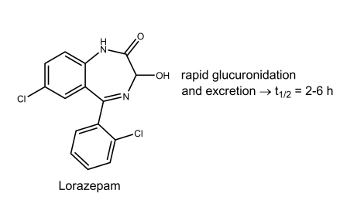
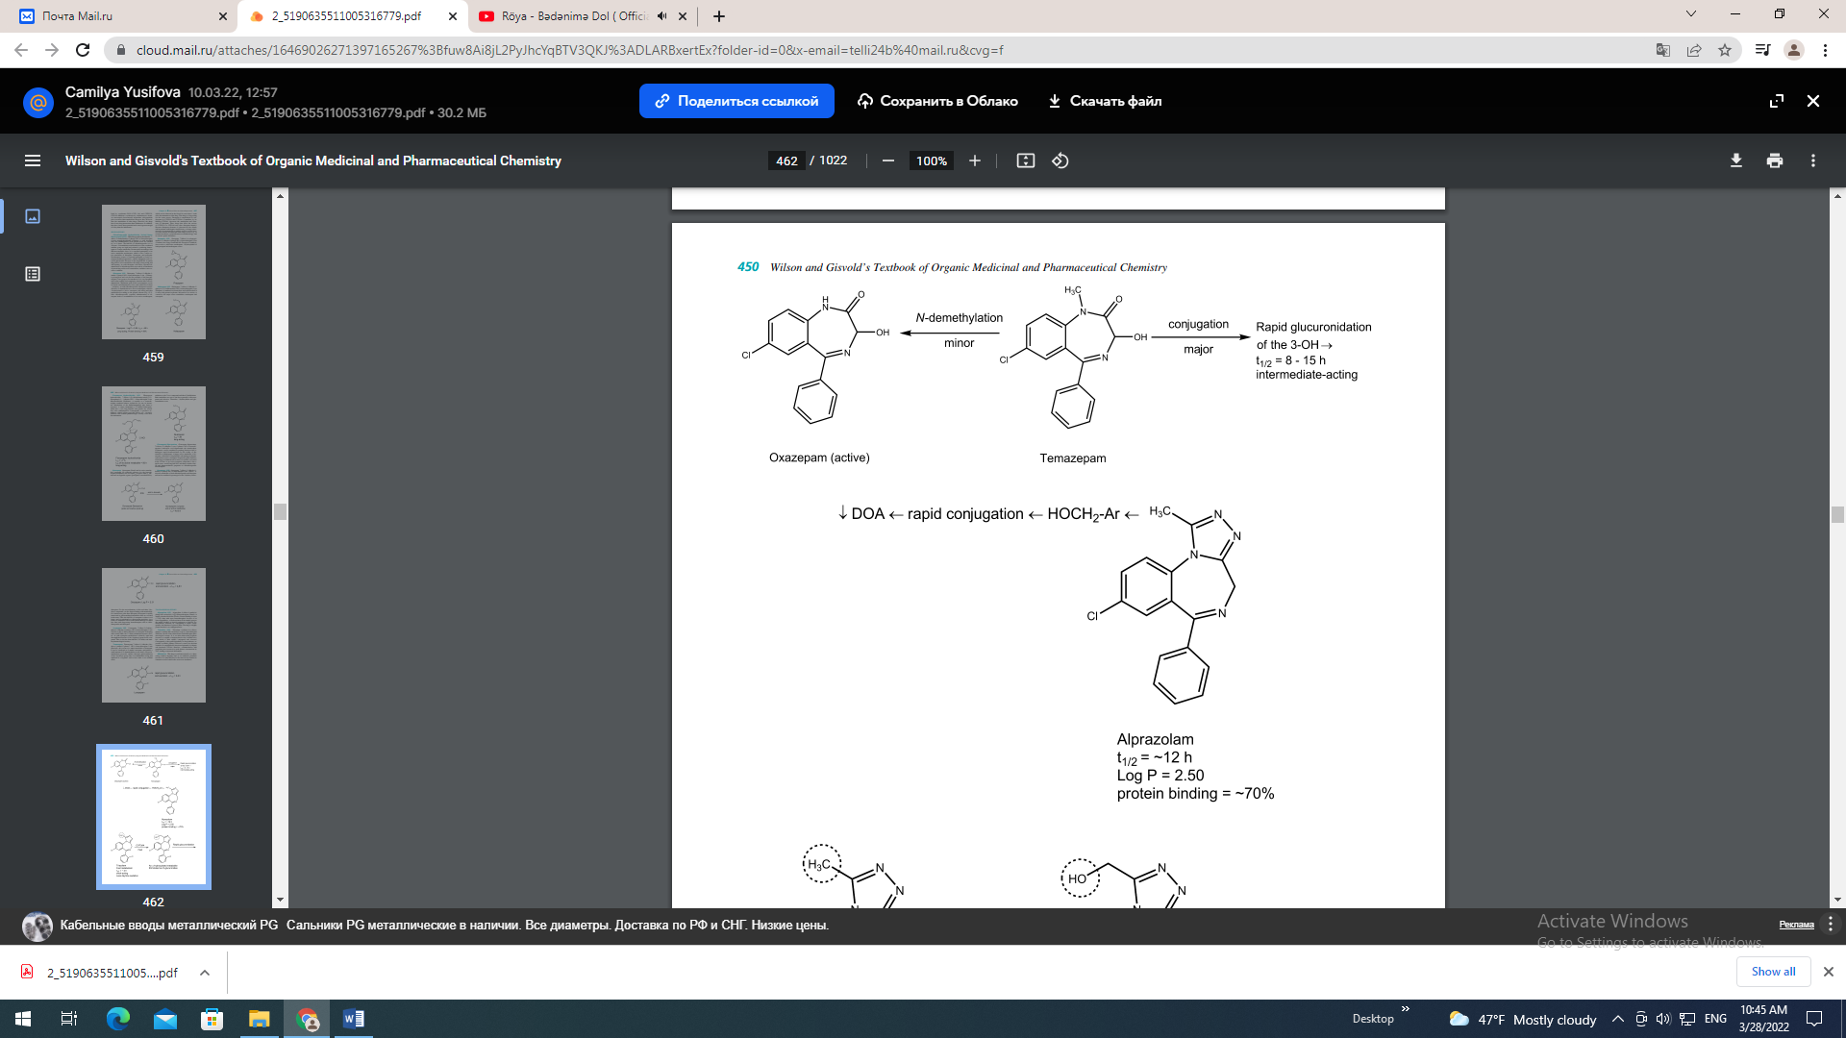
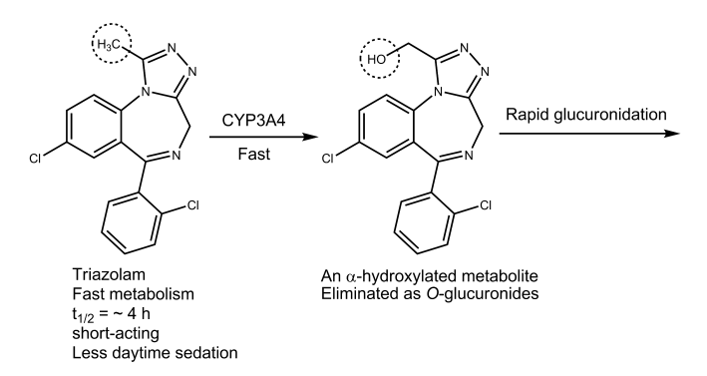
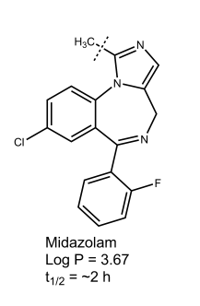
NONBENZODIAZEPINE BzRAs Zolpidem (Ambien, an imidazopyridine) and eszopiclone (Lunesta, a cyclopyrrolone) are nonbenzodiazepines and have been introduced as short- and moderate-acting hypnotics, respectively. Zolpidem exhibits a high selectivity for the 1 subunit of benzodiazepinebinding site on GABAA receptor complex, whereas eszopiclone is a “superagonist” at BzRs with the subunit composition 122 and 123. Zolpidem has a rapid onset of action of 1.6 hours and good bioavailability (72%), mainly because it is lipophilic and has no ionizable groups at physiological pH. Food can prolong the time to peak concentration without affecting the half-life probably for the same reason. It has short elimination half-life, because its aryl methyl groups is extensively -hydroxylated to inactive metabolites by CYP3A4 followed by further oxidation by aldehyde dehydrogenase to the ionic carboxylic acid. The metabolites are inactive, short-lived, and eliminated in the urine. Its half-life in the elderly or the patients with liver disease is increased. Therefore, dosing should be modified in patients with hepatic insufficiency and the elderly. Because it has longer elimination half-life than zaleplon, it may be preferred for sleep maintenance. It was the most commonly prescribed drug for insomnia in 2001. Zopiclone was originally marketed as a racemic mixture. Because its S-isomer is a primary active hypnotic, it is now marketed as eszopiclone in the United States. It is less selective for the 1 subunit of GABAA receptor, and it has relatively longer elimination half-life (6 hours) than zolpidem and zaleplon. Consequently, it may be used for patients who tend to awaken during the night. Zaleplon. Zaleplon (Sonata, a pyrazolopyrimidine) is another short-acting nonbenzodiazepine hypnotic. Pharmacologically and pharmacokinetically, zaleplon is similar to zolpidem; both are hypnotic agents with short halflives. It also has selective high affinity for 1-subunit containing BzRs but produces effects at other BzR/GABAA subtypes as well. Zaleplon is well absorbed following oral administration with an absolute bioavailability of approximately 30% because of significant presystemic metabolism. It exhibits a mean half-life of approximately 1 hour, with less than 1% of the dose excreted unchanged in urine. It is primarily metabolized by aldehyde oxidase to 5-oxo-zaleplon and is also metabolized to a lesser extent by CYP3A4. Ndemethylation yields desethylzaleplon, which is quickly converted, presumably by aldehyde oxidase, to 5-oxo-desethylzaleplon. These oxidative metabolites are then converted to glucuronides and eliminated in urine. All of zaleplon’s metabolites are pharmacologically inactive. It may have a more rapid onset (about 1 hour) and termination of action than zolpidem, and therefore, it is good to initiate sleep instead of keeping sleep. Melatonin Receptor Agonist: Ramelteon In the brain, three melatonin receptors (MT1, MT2, and MT3) have been characterized. Activation of the MT1 receptor results in sleepiness, whereas the MT2 receptor may be related to the circadian rhythm. MT3 receptors may be related to intraocular pressure. Their endogenous ligand, melatonin (N-acetyl-5-methoxytryptamine), at times referred to as “the hormone of darkness,” is N-acetylated and O-methylated product of serotonin found in the pineal gland and is biosynthesized and released at night and may play a role in the circadian rhythm of humans. It is promoted commercially as a sleep aid by the food supplement industry. However, it is a poor hypnotic drug because of its poor potency, poor absorption, poor oral bioavailability, rapid metabolism, and nonselective effects.
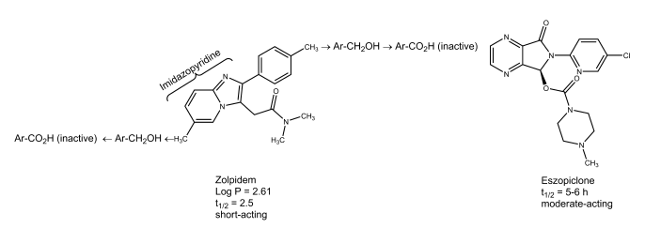
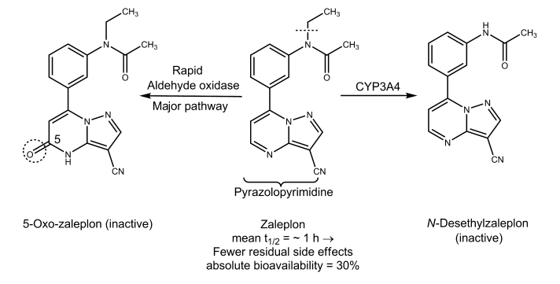
Ramelteon (Rozerem). The melatonin molecule was modified mainly by replacing the nitrogen of the indole ring with a carbon to give an indane ring and by incorporating 5- methoxyl group in the indole ring into a more rigid furan ring. The selectivity of the resulting ramelteon for MT1 receptor is eight times more than that of MT2 receptor. Unlike melatonin, it is more effective in initiating sleep (MT1 activity) rather than to readjust the circadian rhythm (MT2 activity). It appears to be distinctly more efficacious than melatonin but less efficacious than benzodiazepines as a hypnotic. Importantly, this drug has no addiction liability (it is not a controlled substance). As a result, it has recently been approved for the treatment of insomnia. Barbiturates The barbiturates were used extensively as sedative–hypnotic drugs. Except for a few specialized uses, they have been replaced largely by the much safer benzodiazepine. Barbiturates act throughout the CNS. However, they exert most of their characteristic CNS effects mainly by binding to an allosteric recognition site on GABAA receptors that positively modulates the effect of the GABAA receptor— GABA binding. Unlike benzodiazepines, they bind at different binding sites and appear to increase the duration of the GABA-gated chloride channel openings. In addition, by binding to the barbiturate modulatory site, barbiturates can also increase chloride ion flux without GABA attaching to its receptor site on GABAA. This has been termed a GABA mimetic effect. It is thought to be related to the profound CNS depression that barbiturates can produce. The barbiturates are 5,5-disubstituted barbituric acids. Consideration of the structure of 5,5-disubstituted barbituric acids reveals their acidic character. Those without methyl substituents on the nitrogen have pKa’s of about 7.6; those with a methyl substituent have pKa’s of about 8.4. The free acids have poor water solubility and good lipid solubility (the latter largely a function of the two hydrocarbon substituents on the 5-position, although in the 2-thiobarbiturates, the sulfur atom increases lipid solubility). Sodium salts of the barbiturates are readily prepared and are water soluble. Their aqueous solutions generate an alkaline pH. A classic incompatibility is the addition of an agent with an acidic pH in solution, which results in formation and precipitation of the free water-insoluble disubstituted barbituric acid. Sodium salts of barbiturates in aqueous solution decompose at varying rates by basecatalyzed hydrolysis, generating ring-opened salts of carboxylic acids.
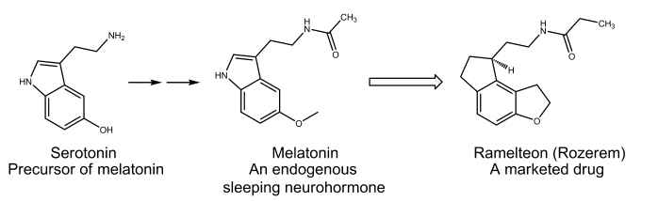
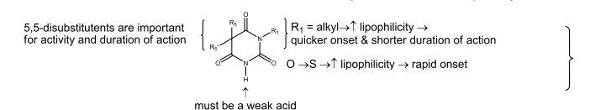
Structure–Activity Relationships Extensive synthesis and testing of the barbiturates over a long time span have produced well-defined SARs (see Fig. 12.3), which have been summarized.18 The barbituric acid is 2,4,6-trioxohexahydropyrimidine, which lacks CNS depressant activity. However, the replacement of both hydrogens at position 5 with alkyl or aryl groups confers the activity. Both hydrogen atoms at the 5-position of barbituric acid must be replaced. This may be because if one hydrogen is available at position 5, tautomerization to a highly acidic trihydroxypyrimidine (pKa 4) can occur. Consequently, the compound is largely in the anionic form at physiological pH, with little nonionic lipid-soluble compound available to cross the blood-brain barrier. In general, increasing lipophilicity increases hypnotic potency and the onset of action and decreases the duration of action. Thus, beginning with lower alkyls, there is an increase in onset and a decrease in duration of action with increasing hydrocarbon content up to about seven to nine total carbon atoms substituted on the 5-position. It is because that lipophilicity and an ability to penetrate the brain in the first case and an ability to penetrate liver microsomes in the second may be involved. In addition for more lipophilic compounds, partitioning out of the brain to other sites can be involved in the second instance. There is an inverse correlation between the total number of carbon atoms substituted on the 5-position and the duration of action, which is even better when the character of these substituents is taken into account, for example, the relatively polar character of a phenyl substituent (approximates a three- to four-carbon aliphatic chain), branching of alkyls, presence of an isolated double or triple bond, and so on. Additionally, these groups can influence the ease of oxidative metabolism by effects on bond strengths as well as by influencing partitioning. Absorption from the GI tract is good. Binding to blood proteins is substantial. Compounds with low lipophilicity may be excreted intact in the urine, whereas highly lipophilic compounds are excreted after metabolism to polar metabolites. Increasing the lipophilicity generally increases the rate of metabolism, except for compounds with an extremely high lipophilicity (e.g., thiopental), which tend to depotize and are thus relatively unavailable for metabolism. Metabolism generally follows an ultimate ( ) or penultimate ( -1) oxidation pattern. Ring-opening reactions are usually minor. N-methylation decreases duration of action, in large part, probably, by increasing the concentration of the lipid-soluble free barbituric acid. 2-Thiobarbiturates have a very short duration of action because its lipophilicity is extremely high, promoting depotization. Barbiturates find use as sedatives, as hypnotics, for induction of anesthesia, and as anticonvulsants. Some of the more frequently used barbiturates are described briefly in the following sections. For the structures, the usual dosages required to produce sedation and hypnosis, the times of onset, and the duration of action, see Table 12.1. BARBITURATES WITH A LONG DURATION OF ACTION (MORE THAN 6 HOURS) Mephobarbital, USP. Mephobarbital, 3-methyl-5- ethyl-5-phenylbarbituric acid (metharbital), is metabolically N-demethylated to phenobarbital, which many consider to account for almost all of the activity. Its principal use is as an anticonvulsant.
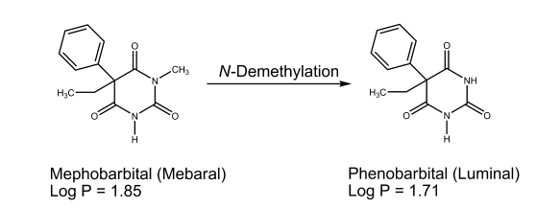
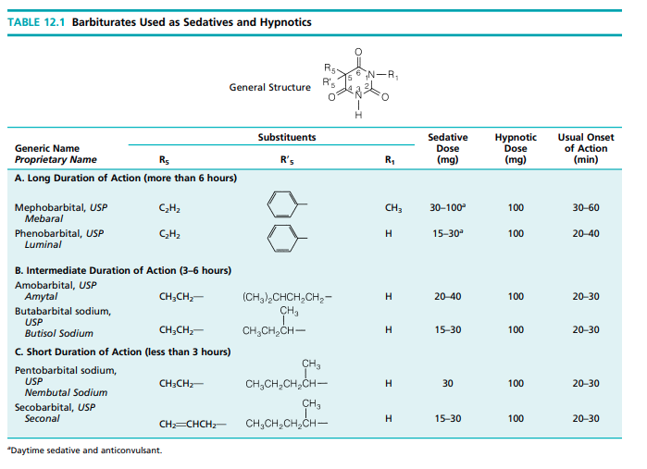

Phenobarbital, USP. Phenobarbital, 5-ethyl-5-phenylbarbituric acid (Luminal), is a long-acting sedative and hypnotic. It is also a valuable anticonvulsant, especially in generalized tonic–clonic and partial seizures (see the discussion on anticonvulsants). Metabolism to the p-hydroxylphenyl compound followed by glucuronidation accounts for about 90% of a dose.
BARBITURATES WITH AN INTERMEDIATE
DURATION OF ACTION (3–6 HOURS)
Barbiturates with an intermediate duration of action are used principally as sedative–hypnotics. They include amobarbital, USP, 5-ethyl-5-isopentylbarbituric acid (Amytal), and its water-soluble sodium salt, amobarbital sodium, USP, 5- allyl-5-isopropylbarbituric acid (aprobarbital [Alurate]); butabarbital sodium, USP, the water-soluble sodium salt of 5-sec-butyl-5-ethylbarbituric acid (Butisol Sodium). BARBITURATES WITH A SHORT DURATION OF ACTION (LESS THAN 3 HOURS) Barbiturates that have substituents in the 5-position promoting more rapid metabolism (e.g., by increasing the lipophilicity) than the intermediate group include pentobarbital-sodium, USP, sodium 5-ethyl-5-(1-methylbutyl)barbiturate (Nembutal); secobarbital, USP, 5-allyl-5-(1-methylbutyl)barbituric acid (Seconal); and the sodium salt sodium secobarbital. Barbiturates with an ultrashort duration of action are discussed under anesthetic agents. Miscellaneous Sedative–Hypnotics A wide range of chemical structures (e.g., imides, amides, alcohols) can produce sedation and hypnosis resembling those produced by the barbiturates. Despite this apparent structural diversity, the compounds have generally similar structural characteristics and chemical properties: a nonpolar portion and a semipolar portion that can participate in
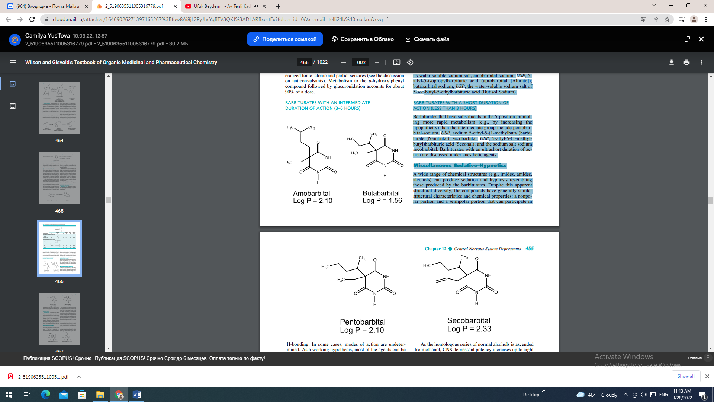
H-bonding. In some cases, modes of action are undetermined. As a working hypothesis, most of the agents can be envisioned to act by mechanisms similar to those proposed for barbiturates and alcohols. AMIDES AND IMIDES Glutethimide, USP. Glutethimide, 2-ethyl-2-phenylglutarimide (Doriden), is one of the most active nonbarbiturate hypnotics that is structurally similar to the barbiturates, especially phenobarbital. Because of glutethimide’s low aqueous solubility, its dissolution and absorption from the GI track is somewhat erratic. Consistent with its high lipophilicity, it undergoes extensive oxidative metabolism in the liver with a half-life of approximately 10 hours. Glutethimide is used as a racemic mixture with the () enantiomer being primarily metabolized on the glutarimide ring and the () enantiomer on the phenyl ring. The product of metabolic detoxification is excreted after conjugation with glucuronic acid at the hydroxyl group. The drug is an enzyme inducer. In the therapeutic dosage range, adverse effects tend to be infrequent. Toxic effects in overdose are as severe as, and possibly more troublesome than, those of the barbiturates. Alcohols and Their Carbamate Derivatives The very simple alcohol ethanol has a long history of use as a sedative and hypnotic. Its modes of action were described under the anesthetic heading and are said to apply to other alcohols. It is widely used in self-medication as a sedative–hypnotic. Because this use has so many hazards, it is seldom a preferred agent medically. As the homologous series of normal alcohols is ascended from ethanol, CNS depressant potency increases up to eight carbon atoms, with activity decreasing thereafter. Branching of the alkyl chain increases depressant activity and, in an isometric series, the order of potency is tertiary secondary primary. In part, this may be because tertiary and secondary alcohols are not metabolized by oxidation to the corresponding carboxylic acids. Replacement of a hydrogen atom in the alkyl group by a halogen increases the alkyl portion and, accordingly, for the lower–molecular weight compounds, increases potency. Carbamylation of alcohols generally increases depressant potency. Carbamate groups are generally much more resistant to metabolic inactivation than hydroxyl functions. Most of the alcohols and carbamates have been superseded as sedative–hypnotics. Several difunctional compounds (e.g., diol carbamates) have depressant action on the cord in addition to the brain and are retained principally for their skeletal muscle relaxant properties. Ethchlorvynol, USP. Ethchlorvynol, 1-chloro-3-ethyl-1- penten-4-yn-3-ol (Placidyl), is a mild sedative–hypnotic with a quick onset and short duration of action (t1/2 5.6 hours). Because of its highly lipophilic character, it is extensively metabolized to its secondary alcohol (90%) prior to its excretion. It reportedly induces microsomal hepatic enzymes. Acute overdose shares several features with barbiturate overdose. Meprobamate, USP. Meprobamate, 2-methyl-2- propyltrimethylene dicarbamate, 2-methyl-2-propyl-1,3- propanediol dicarbamate (Equanil, Miltown), is officially indicated as an antianxiety agent. It is also a sedative– hypnotic agent. It has several overall pharmacological
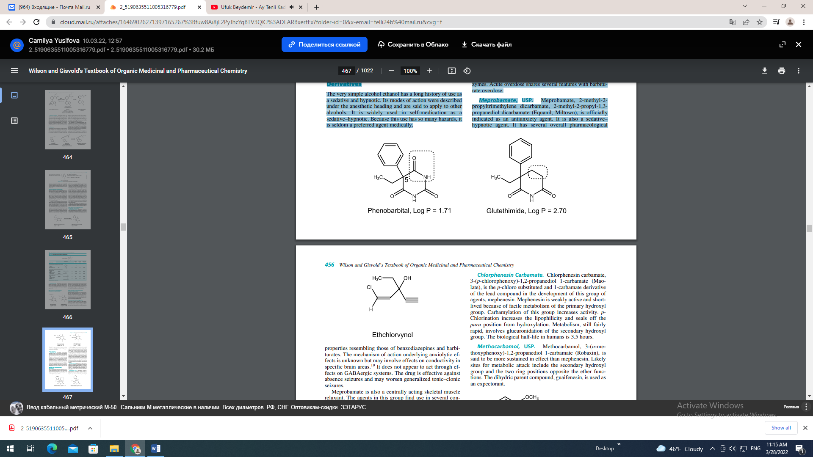
properties resembling those of benzodiazepines and barbiturates. The mechanism of action underlying anxiolytic effects is unknown but may involve effects on conductivity in specific brain areas.19 It does not appear to act through effects on GABAergic systems. The drug is effective against absence seizures and may worsen generalized tonic–clonic seizures. Meprobamate is also a centrally acting skeletal muscle relaxant. The agents in this group find use in several conditions, such as strains and sprains that may produce acute muscle spasm. They have interneuronal blocking properties at the level of the spinal cord, which are said to be partly responsible for skeletal muscle relaxation.19 Also, the general CNS depressant properties they possess may contribute to, or be mainly responsible for, the skeletal muscle relaxant activity. Dihydric compounds and their carbamate (urethane) derivatives, as described previously in the discussion of meprobamate, are prominent members of the group.
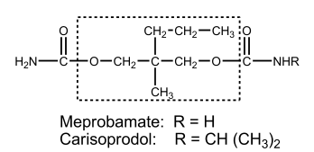
Carisoprodol, USP. Carisoprodol, N-isopropyl-2- methyl-2-propyl-1,3-propanediol dicarbamate, 2-methyl-2- propyl-1,3-propanediol carbamate isopropylcarbamate (Soma), is the mono-N-isopropyl–substituted relative of meprobamate. The structure is given in the discussion of meprobamate. It is indicated in acute skeletomuscular conditions characterized by pain, stiffness, and spasm. As can be expected, a major side effect of the drug is drowsiness.
Chlorphenesin Carbamate. Chlorphenesin carbamate, 3-(p-chlorophenoxy)-1,2-propanediol 1-carbamate (Maolate), is the p-chloro substituted and 1-carbamate derivative of the lead compound in the development of this group of agents, mephenesin. Mephenesin is weakly active and shortlived because of facile metabolism of the primary hydroxyl group. Carbamylation of this group increases activity. pChlorination increases the lipophilicity and seals off the para position from hydroxylation. Metabolism, still fairly rapid, involves glucuronidation of the secondary hydroxyl group. The biological half-life in humans is 3.5 hours. Methocarbamol, USP. Methocarbamol, 3-(o-methoxyphenoxy)-1,2-propanediol 1-carbamate (Robaxin), is said to be more sustained in effect than mephenesin. Likely sites for metabolic attack include the secondary hydroxyl group and the two ring positions opposite the ether functions. The dihydric parent compound, guaifenesin, is used as an expectorant.
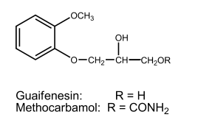
ALDEHYDES AND THEIR DERIVATIVES For chemical reasons that are easily rationalized, few aldehydes are valuable hypnotic drugs. The aldehyde in use, chloral (as the hydrate), is thought to act principally through a metabolite, trichloroethanol. Acetaldehyde is used as the cyclic trimer derivative, paraldehyde, which could also be grouped as a cyclic polyether. Chloral Hydrate, USP. Chloral hydrate, trichloroacetaldehyde monohydrate, CCl3CH(OH)2 (Noctec), is an aldehyde hydrate stable enough to be isolated. The relative stability of this gem-diol is largely a result of an unfavorable dipole–dipole repulsion between the trichloromethyl carbon and the carbonyl carbon present in the parent carbonyl compound.20 Chloral hydrate is unstable in alkaline solutions, undergoing the last step of the haloform reaction to yield chloroform and formate ion. In hydroalcoholic solutions, it forms the hemiacetal with ethanol. Whether or not this compound is the basis for the notorious and potentially lethal effect of
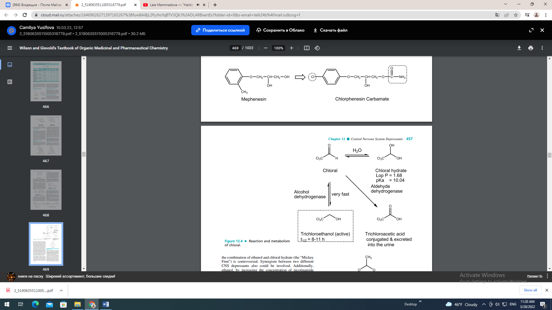
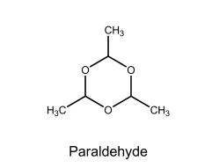
the combination of ethanol and chloral hydrate (the “Mickey Finn”) is controversial. Synergism between two different CNS depressants also could be involved. Additionally, ethanol, by increasing the concentration of nicotinamide adenine dinucleotide (NADH), enhances the reduction of chloral to the more active metabolite trichloroethanol, and chloral can inhibit the metabolism of alcohol because it inhibits alcohol dehydrogenase. Chloral hydrate is a weak acid because its CCl3 group is very strong electron withdrawing. A 10% aqueous solution of chloral hydrate has pH 3.5 to 4.4, which makes it irritating to mucous membranes in the stomach. As a result, GI upset commonly occurs for the drug if undiluted or taken on an empty stomach. Chloral hydrate as a capsule, syrup, or suppository is currently available. Although it is suggested that chloral hydrate per se may act as a hypnotic,21 chloral hydrate is very quickly converted to trichloroethanol, which is generally assumed to account for almost all of the hypnotic effect. The trichloroethanol is metabolized by oxidation to chloral and then to the inactive metabolite, trichloracetic acid (see Fig. 12.4), which is also extensively metabolized to acylglucuronides via conjugation with glucuronic acid. It appears to have potent barbiturate-like binding to GABAA receptors. Although an old drug, it still finds use as a sedative in nonoperating room procedures for the pediatric patient. Paraldehyde, USP. Paraldehyde, 2,4,6-trimethyl-strioxane, paracetaldehyde, is recognizable as the cyclic trimer of acetaldehyde. It is a liquid with a strong characteristic odor detectable in the expired air and an unpleasant taste. These properties limit its use almost exclusively to an institutional setting (e.g., in the treatment of delirium tremens). In the past, when containers were opened and air admitted and then reclosed and allowed to stand, fatalities occurred because of oxidation of paraldehyde to glacial acetic acid.

